  
**The Forest Federation**

**of Soudley, Steam Mills and Woodside Primary Schools**

**Behaviour principles written statement**

**Date: Sept 2025**

Article 3: The best interests of the child must be a top priority in all decisions and actions that affect children.

Article 12: Every child has the right to express their views, feelings and wishes in all matters affecting them, and to have their views considered and taken seriously.

Article 28: Every child has the right to an education.

**Forest Federation Vision**

**We nurture a love of life, love of learning and mutual respect. We aim to provide a stimulating and challenging environment where everyone is happy, valued and every voice is heard. We want children to leave our schools equipped with the skills to become valued and responsible members of the community.**

The Forest Federation is committed to ensuring high behaviour standards for all pupils, and this statement sets out the broad values and principles for behaviour that are expected and promoted.

This statement has been approved by the executive headteacher and the governing board, believing it accurately reflects the school’s ethos and that effective learning and development relies on good standards of behaviour. See the Behaviour Policy for details of our practice.

**Principles**

To ensure the safety, wellbeing and education of all pupils:

* The schools will create calm and orderly environments to enable pupils to learn effectively.
* The schools will promote self-esteem, self-discipline, proper regard for authority, and positive relationships based on mutual respect.
* The schools create positive and respectful cultures in which staff know and care about pupils.
* The schools ensure that all pupils, staff and visitors feel safe in the school environment through a high quality of care, support and guidance.
* Good behaviour at school is acknowledged and rewarded by all staff
* Pupils are held to high standards of attendance. The school will take swift, appropriate and action to ensure that problems of lateness and absence are handled effectively.
* Staff lead by example and model their conduct in line with the school’s standards.This statement, and the policies that are influenced by it, applies to all pupils and staff inside and outside of school.
* The schools offer comprehensive support to pupils displaying problematic behaviour, before and/or alongside disciplinary measures, taking into account pupils’ home circumstances and any SEND.

**We believe that:**

* All pupils have a right to fulfil their academic and personal potential and to feel they are valued members of the school community
* Pupils should be free from bullying, discrimination and distracting peer behaviour.
* All pupils are expected to behave consistently well, demonstrating high levels of self-control and consistently positive attitudes to their education.

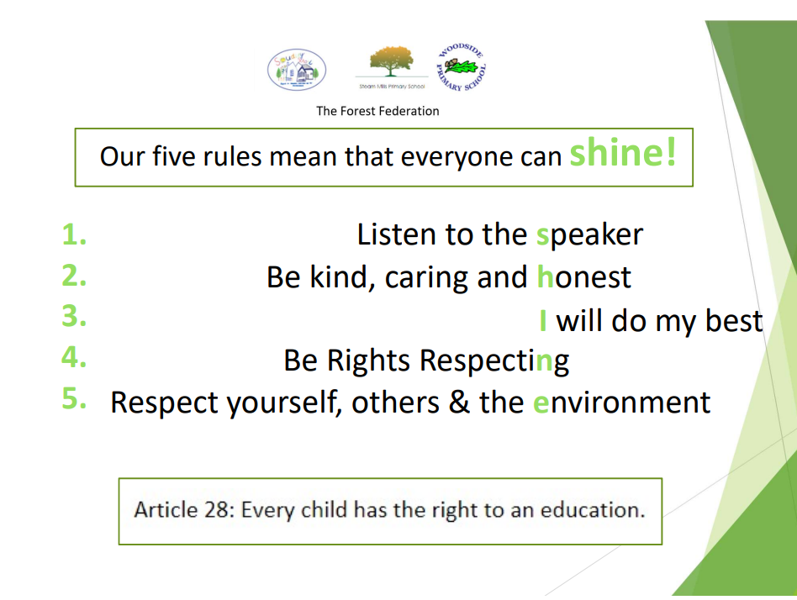The school ensures that rules that reflect and are consistent with the messages taught across the curriculum are consistently applied across the school and, where sanctions are exercised, they are in line with the school’s Behaviour Policy and are taken seriously.

Actions taken in cases of inappropriate behaviour are with the intention of upholding pupils’ wellbeing and academic progress, as well as fulfilling our safeguarding responsibilities.

**Non-negotiables:**

* Any kind of violence, threatening behaviour or abuse between pupils, or by members of the school community towards the school’s staff, will not be tolerated.