
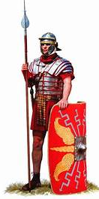
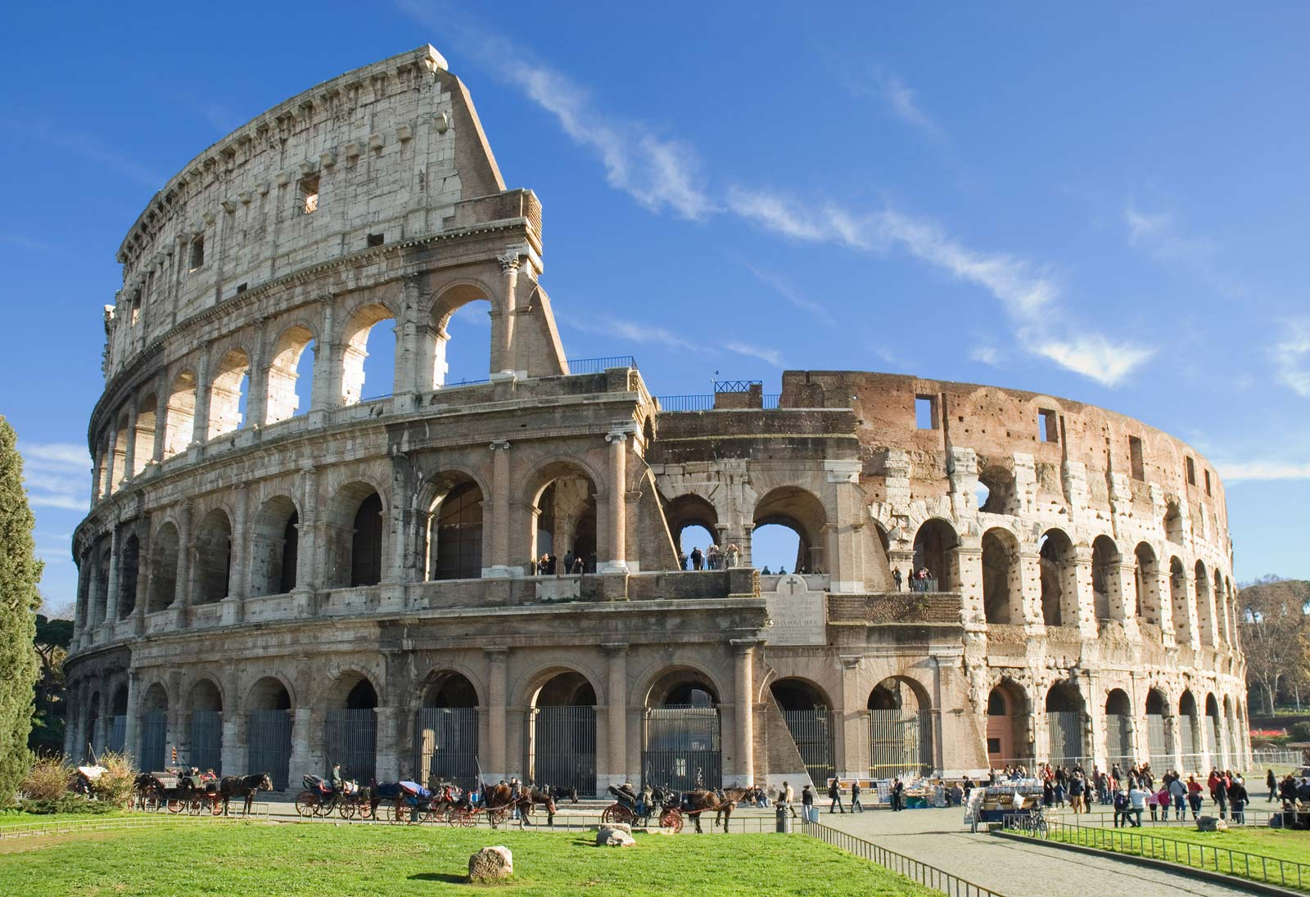
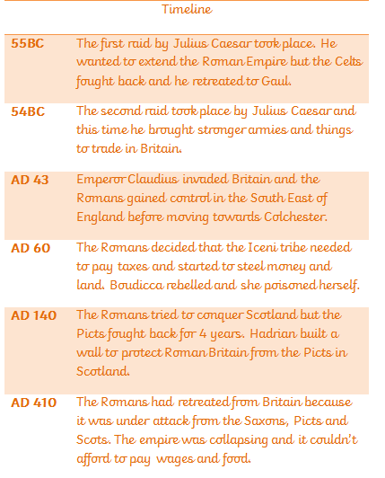
The Ruthless Romans! Class 3 Summer 2021
Fun facts!
Toilets- the Romans used a sponge on a stick rather than toilet paper to clean themselves.
Baths- the Romans enjoyed leisure time and built baths. They would have saunas, tepidariums and frigidariums- just like spas today!
Gods and Goddesses- The Romans worshiped many Gods and Goddesses such as Mars the God of war and Venus the Goddess of love.
An amphitheatre can be nearby in Caerleon, Wales.

