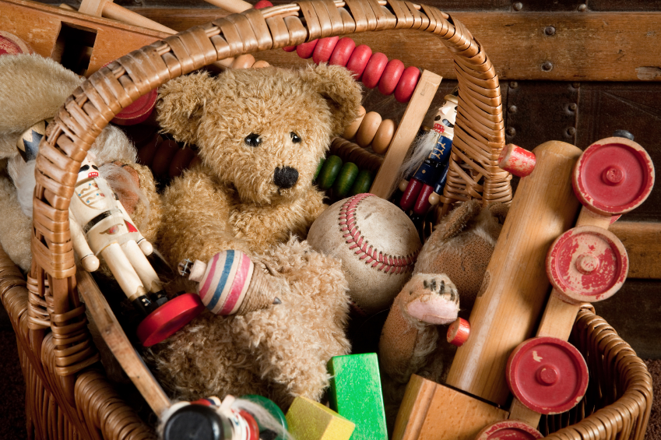

Rights Respecting

Rights linked with having toys.

Children around the world.

Global Learning

Theme: Care

Skill: Enquiry and Discussion

* Recognise the difference between toys of the past and those of today.
* Compare toys from the world and consider whether all children have the same access to toys.
* Investigate toys made from recycled materials.
* Create art work based on their own toys.

**Toys Year 1**

**Essential Knowledge**

**By the end of this unit children will know...**

**Celebrate**

Have old toys into school through a museum outreach scheme.

**Energise**

Children research types of toys in their family - what toys did your parents play with?

What materials are toys made out of? How do toys move?

Create a class museum to share information about old toys.

**Launch**

Children find out what they know about toys already and talk about what they would like to find out.

**Explore**

* Identifying and classifying
* Identify and name a variety of common animals including fish, amphibians, reptiles, birds and mammals.
* Describe and compare the structure of a variety of common animals.

**History:**

* Recognise the difference between toys of the past and those of today.
* Sequence toys from today and those from previous generations in a timeline.
* Ask and answer questions about toys from the past.
* Use time language such as yesterday, last week, a long time ago.

**Geography:**

* Compare toys from around the world.

**Art and Design and Design Technology**

**Art:**

* Teddy bear art work based on work by A. A. Milne
* Toy collages

**Design Technology:**

* Design and make a peg doll, sock puppet or moving puppet.

 P.E.: Orienteering and ball skills.

Music: Listening to famous composers.

**Computing**

E-Safety: Keeping myself safe online

Who and when should I share my personal information?

**Music, Languages and Physical Education**

* Recount writing.
* Story ‘The Lonely Bear’ – letter writing
* Descriptive writing — describe a favourite toy.
* Poetry – based on ‘This is the Bear.

**Mathematics**

* Number and place value.
* Identify and describe 2D and 3D shapes.

**Science**

**History, Geography and Citizenship**

**Foundation Subjects**

* Compare toys from around the world.
* Investigate toys made from recycled materials.

**Cultural**

* Working collaboratively.
* Consider whether all children have the same access to toys.

**Social**

* What rights do children have? Is it fair that not all children can have new toys?

**Moral**

* Compare birthing and/or naming rituals between different cultures.

**Spiritual**

**English**

**Core Subjects: Links to theme**

**Personal Development**

**Toys Year 1: Theme Content**