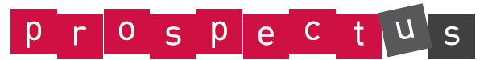
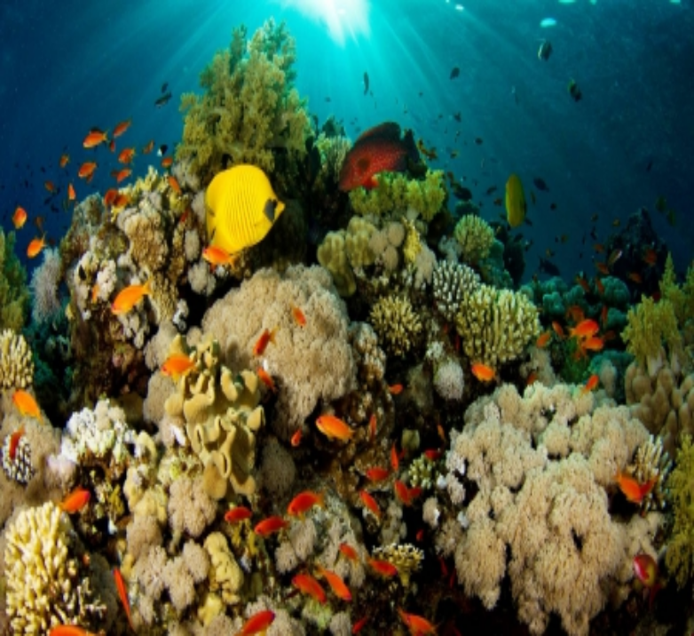
What Lies Below?: Reception and Year One

Essential Knowledge

By the end of this unit children will know...

- As Design Technologists the children will explore designing and creating their own musical instruments which they can play. Children will also make their own puppets based on a character from Commotion in the Ocean.
- As Scientists the children will investigate floating and sinking. The children will carry out investigations into materials and then use different resources and materials to create their own boat.
- As Geographers the children will explore locating the different continents and oceans on a map. We will also compare several seaside locations.
- As Writers the children will story writing, instructional writing, riddles and poetry (Commotion in the Ocean), thank you letters and reports (Linked to Science).
- As Mathematicians we will explore place value, addition and subtraction, doubling, halving, position, distance, money and weight.
- During ICT children will learn how to program and use a range of technology.
- As Historians we will look at famous explorers and explore key events in their lives.
- During PSHE we will explore Kindness and Anti-Bullying (PINK curriculum) and also how to keep myself safe around the sea and the sun (PINK Curriculum topic)
- During PE children will build upon their football and athletic skills.

Let’s Celebrate!
Invite parents in to view the children’s work from the topic. To share their homework, books and learning journeys on the tables.

Celebrate

Let’s go wild!
To make and then host their own puppet show to the class and video.

Explore

Let’s model!
To design and create their own pirate boats as part of a Floating and Sinking Science experiment.

Launch

Let’s Imagine!
PSHE Link
To read the story of the rainbow fish. What makes us different? Can they create their own unique rainbow fish?
.

Energise
Aspirations
- Learning about how to take care of the planet
- Considering carers linked to the sea e.g. Marine Biologist.

Enterprise
Pupil Voice.
Global Learning projects.
We will also make a collaborative display for our topic lead by the children and their learning.
Hosting their own puppet show for parents.

Knowledge of the World
To find out about different countries around the world (Drink and Think/GLP).
To find out about Special Places (RE)
Climate change and the effects on Bangladesh
Diversity –celebrating differences.

Global Learning Link (Theme –Diversity) To teach through PSHE – Rainbow Fish.
Aim: Pupils become aware of similarities and differences between people, improve their listening skills, and gain a sense of identity and self-worth.
- To also mention climate change and how this effects the sea.
- To explore Bangladesh and the impact of Climate change. What is it like for a child living in Bangladesh?
Rights Respecting link: Article 2, Article 12, Article 24, Article 27.

What Lies Below - Reception/Year 1: Theme Content

Core Subjects:
Links to theme

Personal Development

Foundation Subjects

Literacy/English
History, Geography and RE

Communication and Language
- To Sequence and order a story from beginning, middle to end.
- To create their own story
- To create my own recount of our class trip to the aquarium.
- To orally retell a story using story language.
- To write a postcard.
- To create a poster (Link to ICT)
- To explore poetry and rhyming (Commotion in the Ocean)
- Instructional writing.
- Spellings.
Geography:
- Children to name and locate the world’s 7 continents on a map.
- To name different countries within Europe.
- To compare different sea side locations.
- To discuss and compare the weather
- To explore physical and human geography.
History
- The History of the seaside
- Christopher Columbus – who is he? Why is he famous?
RE:
- To talk about and explore the different religious faiths and religions through Global Learning- Drink and Think.
- Special People Topic.

- Pie Corbett Story Telling
- All About Me Box
- PSHE/Circle Time
- Spencer Bear
- Drink and Think.

Spiritual
Mathematics
Maths sessions based around:

- Counting in 2’s, 5’s and 10’s.
- Measurement – ½ measurements.
- Place value.
- Position and direction
- Addition and subtraction
- Doubling and halving.
- Problem Solving.
- Money

Starter activities aimed towards:
- Number rhymes.
- Number Bonds to 20.
- Number recognition 20/100.
- 2d and 3d shapes

Science
- Floating and Sinking.(Following on from last topic)
- Materials.
- Seasons/Weather – look at spring.

- To think about the spiritual meaning within special places from around the world (RE topic link)

Art and Design, Design Technology and Music

DT:
- To create their own Pirate boats.
- To design their own boat – using labels and a list of what resources they will need.
- To explore using different tools and techniques.
- Tinker table in the Outdoor Area – Children to explore using real tools and resources and create

Music:
Children to learn the Sing Up song – I do want to be beside the seaside
To create and then play different instruments to create a seaside song.
To explore the sound of the sea.

UTW: Computing

- To carry out E-Safety – Smartie the Penguin/Hector the Protector.
- To explore using iPads and Netbooks.
- Code/programming
- Creating a poster for our puppet show.
Moral
- To know the beliefs of different faiths/religions.
- To explore different Biblical stories and their moral meanings.

Social (Linked to PINK curriculum)
- How to keep ourselves safe
- How to be kind and caring to others
Cultural
- Children to respect the traditions and values of different cultures.
- To show a good understanding of different faiths/religions from around the world.
Physical Development
- Athletics.
- Football
Personal, Social, Emotional Development
Tolerance of those with different faiths and beliefs, mutual respect and democracy
British Values

What Lies Below - Reception and Year 1: Links to National Curriculum Framework

Foundation Subjects

Core Subjects:

EAD: Art, Design and Design Technology and Music

DT:
- To use a range of materials creatively to create and make products.
- To use drawing and sculpture to develop and share ideas and imagination.
- To develop a wide range of art and design techniques
- Design purposeful, functional, appealing products for themselves and other users based on design criteria.
- Generate, develop, model and communicate their ideas through talking, drawing and information and communication technology.
Music:
- Use their voices expressively and creatively by singing songs and speaking chants and rhymes
- Play tuned and untuned instruments musically
- Listen with concentration and understanding to a range of high-quality live and recorded music
- Experiment with, create, select and combine sounds using the inter-related dimensions of music.

PD: Physical Education

- Master basic movements including running, jumping, throwing and catching, as well as developing balance, agility and co-ordination, and begin to apply these in a range of activities
- To participate in team games, developing simple tactics for attacking and defending.

Computing

UTW: History, Geography and RE.

- Use technology safely and respectfully, keeping personal information private; identify where to go for help and support when they have concerns about content or contact on the internet or other online technologies
- Use technology purposefully to create, organise, store, manipulate and retrieve digital content
- To use mixed media to create different images and Art.

Geography:
- Name and locate the world’s seven continents and five oceans –continuous.
- To use world maps, atlases and globes to identify the United Kingdom and its countries, as well as the countries, continents and oceans studied at this key stage.
- Understand geographical similarities and differences through studying the human and physical geography of a small area of the United Kingdom, and of a small area in a contrasting non-European country.
- Use basic geographical vocabulary to refer to:
▪ key physical features, including: beach, cliff, coast, forest, hill, mountain, sea, ocean, river, soil, valley, vegetation, season and weather
▪ key human features, including: city, town, village, factory, farm, house, office, port, harbour and shop
History:
- To explore the lives of significant individuals in the past who have contributed to national and international achievements. – Christopher Columbus
- Changes within living memory. Where appropriate, these should be used to reveal aspects of change in national life
RE: - Linked to SACRE
- Special Places
- Drink and Think

Science
Communication and Language (prime)/English (Specific)
- Write sentences by; saying loud what they are going to write about, sequencing sentences.
- Composing a sentence orally before writing it
- Sequencing sentences to form short narratives
- Re-reading what they have written to check that it makes sense
- Participate in discussion about what is read to them, taking turns and listening to what others say.
- Learn rhymes and poems and recite some by heart.
- Use digital texts to find information.
- All of section vocabulary, grammar and punctuation

- Ask simple questions and recognise that they can be answered in different ways.
- Gathering and recording data to help in answering questions.
- Using their observations and ideas to suggest answers to questions.
- Observe changes across the four seasons.
- To distinguish between an object and the material from which it is made.
- To identify and name a variety of everyday materials, including wood, plastic, glass, metal, water, and rock
- To describe the simple physical properties of a variety of everyday materials
- To compare and group together a variety of everyday materials on the basis of their simple physical properties.

Mathematics
- Sequence events in chronological order using language.
- Recognise and use language relating to dates, including days of the week, weeks, months and years
- Solve one-step problems involving multiplication and division.
- Represent and use number bonds and related subtraction facts within 20
- Add and subtract one-digit and two-digit numbers to 20.
- To solve missing number problems.
- To read and write numbers to 20/100.
- To know and name number bonds to 20.
- To count to and across 100, forwards and backwards, beginning with 0 or 1, or from any given number
- To count, read and write numbers to 100 in numerals; count in multiples of twos, fives and tens
- To measure and begin to record the following: Lengths and heights, mass/weight , capacity and volume, time (hours, minutes, seconds)
- To describe position, direction and movement, including whole, half, quarter and three-quarter turns.
- Tell the time to the hour and half past the hour and draw the hands on a clock face to show these times.

- Can children carry out fundamental movements?
- Can children show balance, co-ordination and movement of their body?
- Can children work together?
- Can they move in different ways?
- Can they control a ball? Can they kick and stop a ball? Can they follow the rules? Can they play as a team?

What Lies Below - Reception and Year 1: Assessment Opportunities/Tasks within theme

Core Subjects

Foundation Subjects

Computing

History, Geography and Citizenship

Geography:
- Can children name and locate the world’s seven continents and 5 oceans on a map?
- Can children compare the UK to other countries we find out about?
- Can they name the capitals of the UK?
- Can they compare locations?
- Can they use geographical language?
History:
- Can they identify differences between present and past?
- Can they talk about who Christopher Columbus is?
RE:
- Can they name different religions?
- Can they name different places of worship? Different religious places?
Physical Education

- Can they use mixed media to create pictures and Art?
- Can they complete a simple program?
- Can they select and use ICT for a purpose?
- Do they know and remember how we stay safe when using the internet?
- To know the main tips for staying safe with Smartie the Penguin and Hector the Protector?
Art and Design, Design Technology and Music:

Art & Design:
- What materials will you need?
- Can they design their boat?
- What could you do to improve or better your design?
- What techniques did you use to create your boat?
- What other ways could you make your boat next time?
- Can they confidently use and explore different tools and techniques?
- Can they predict and then test their ideas?
Music:
- Can children play their instrument to make sounds like the sea?
- Can children sing in tune?
- Can children create and then perform their tune?
Science
English
- Can they read a simple sentence or read according to their phonics stage?
- Can they sequence and order the beginning, middle and end in a story?
- Can they identify and continue a rhyming pattern?
- Can they write for a variety of different purposes?
- Can they use a range of punctuation?
- Can they edit their work?
- Can they form their letters correctly?
- Can they verbally re-tell key parts of a story?
- Can they apply their phonological knowledge within their writing?
- Can they write in full sentences?
- Can they write a using the correct pencil grip?
- Can they create a postcard?
- Can they write a letter?
- Can they use description in their writing?
- Can they use connectives?

- Can children find and name different materials?
- Can children carry out an investigation and experiment?
- Can children classify materials by their features?
- Can children compare and group materials?
- Can children collect and use data?
- Can children observe and explain differences about the four seasons?
- Can they use scientific vocabulary?
- Apply skills to real-life contexts?
- Can they solve word and practical problems using a range of skills?
- Can they solve addition and subtraction sums?
- Do they know their number bonds to 20?
- Can they count in 2’s, 5’s and 10’s?
- Can the children name the months of the year and days of the week?
- Can they recognise and use money?
- Can they use numicon and maths resources to help them appropriately?
- Can they recognise and write numbers to 20/100?
- Can they double numbers to 20/100?
- Can they halve numbers to 20/100?
- Can they use positional language?

Mathematics

