Class 2 Will I Need a Coat? Spring Term
UK Weather  - The weather does change a lot in the UK. We can have rain, sun, hail and even snow in a single day. That’s because Britain and Ireland are islands surrounded by sea, and they are open to many different kinds of weather, blowing in from all directions.  - The UK has warm but often wet summers from June to August, and cold also wet winters from December to February.  - The temperature doesn’t vary that much. The average range of temperatures in London is from about 3°C in chilly January, up to a high in July of about 23°C. The meteorologist’s name for the British climate is temperate. | 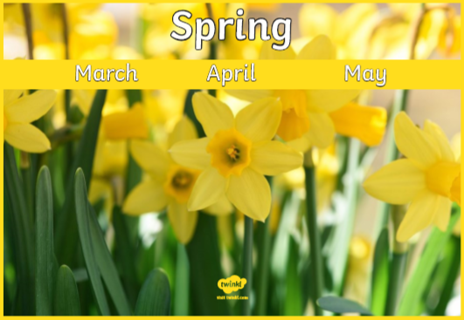 | Often bright with some clouds. | cloudy, windy, cool
 | 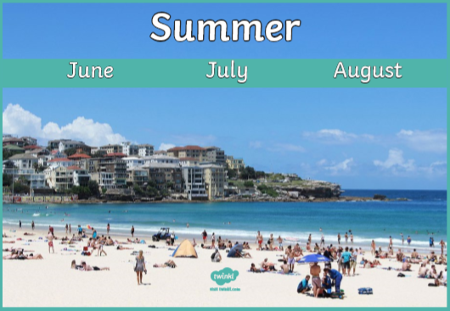 | Rarely heavy rain or strong winds. | hot, breezy, sunny
 | 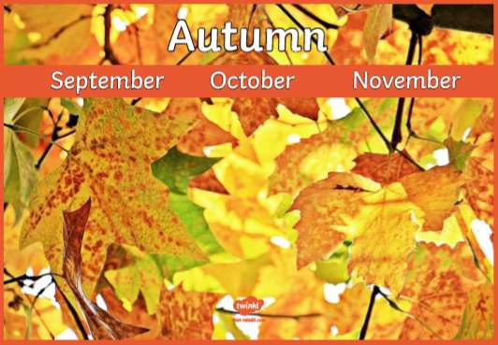 | Often wet and windy. | cold, overcast, wet
 | 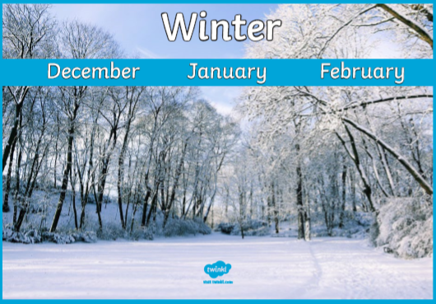 | Often frost on the ground in the morning. | freezing, dark, snowy

Key Words
Weather is the day to day changes to the atmosphere, or air. It can be sunny one day and rainy the next day.
Climate is the average of weather conditions in an area over a long period.
Temperature is a degree of hotness or coldness that can be measured using a thermometer. Temperature is measured in degrees Celsius.
Thermometer is an instrument for measuring temperature
Forecast is a prediction, or good guess, about the future. Weather forecasting is when scientists called meteorologists use many different tools to predict what the weather in the near future will be.
Weather vane is a movable device usually attached to a roof to show which way the wind is blowing.
An Atlas is a collection of maps; usually of maps of Earth or a region of Earth. Atlases are normally bound in a book.
The Equator is an imaginary circle around Earth. It divides Earth into two equal parts: the Northern Hemisphere and the Southern Hemisphere.
Cold, Polar Climates | Finland, Arctic, Norway, Greenland
Warm Climates | Australia, North Africa, Middle East, Mexico
Tropical Climates | Philippines, Indonesia, India, Caribbean
Temperate Climates | United Kingdom, Germany, China, Russia
Inland weather in the UK | Usually less sunshine and wind, but more rain. Often a bot colder than coastal regions
Coastal weather in the UK | Usually gets less rain than inland regions, but more sunshine and wind. Often a bit warmer too.
