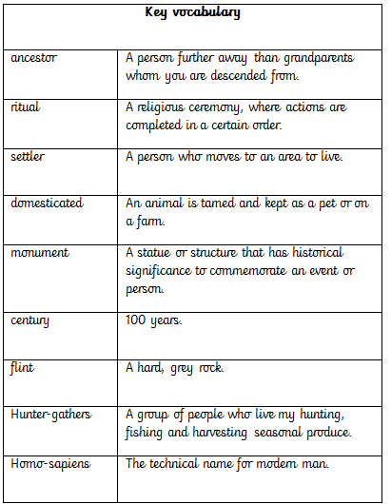
Timeline of events
15,000-10,000BC | Cave paintings were first created in caves such as Lascaux caves in France.
14,000BC | Britain emerged from an ice-age and humans and animals began to re-inhabit the land.
6000BC | Sea levels rose and Britain broke off from the continent of Europe.
4000BC | Settlers arrived from Europe and introduced farming. Animals were tamed.
2500BC | Stone Age ends and metal tools are used. This begins the Bronze Age.
700-500BC | Iron is used more often and this begins the Iron Age period. Hill forts are constructed
43AD | The Romans invade Britain, ending the Iron Age period.
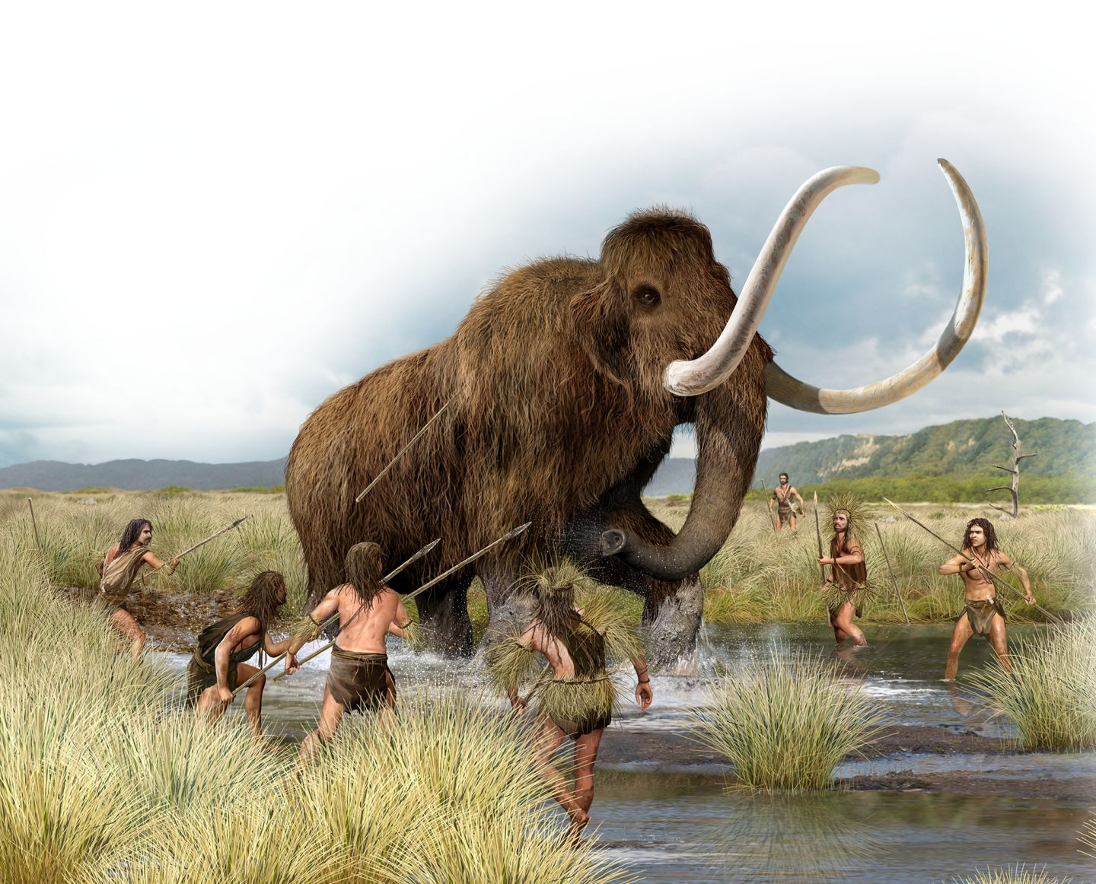
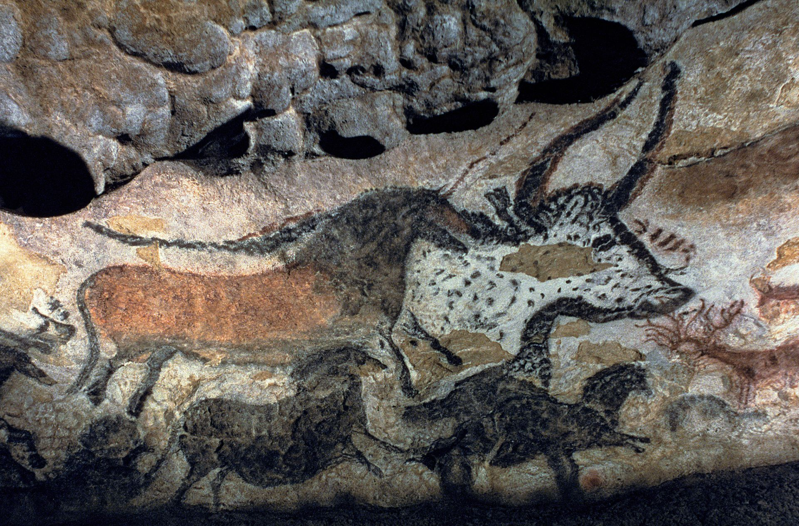
Key facts:
- Stone Age was split into 3 different time zones: Palaeolithic old stone age 30,000BC-10,000BC, 10,000BC-8000BC Mesolithic middle stone age and Neolithic new stone age 8000BC-3000BC.
- 3000BC Communities worked together to build large monuments. These were in forms of mounds of earth or stones places in certain shapes, such as Stonehenge. Humans left ceremonial offerings such as swords, spear heads and daggers.

