Steam Mills wellbeing newsletter October Half Term

All of a sudden it’s half term! I wonder how many of us noticed the speed at which it has arrived, considered the changes we have navigated over the past weeks and the impact they have had on our mental health and wellbeing.
The purpose of this newsletter is to offer some ideas and suggestions for activities linked to looking after our mental health and wellbeing during half term.
If you have any concerns about your child’s mental health/wellbeing, you can contact me via e-schools between 9am and 3.30pm Tuesday to Thursday.
Warm wishes
Miss Fran Barber

Five Ways to Wellbeing… the Steam Mills whoosh!
The ‘Five Ways to Wellbeing’ approach is all about how actions can contribute to and boost feelings of wellbeing. Each of these actions or ways will have a beneficial impact… or the ‘whoosh factor!’
There are some ideas for each of them. We would love to hear how you are getting on via e-schools and any ideas are welcome.
Connect | Activity | Take Notice | Keep Learning | Give
There seems to be a constant state of flux in the ways we are able to connect to others at this time.  I wonder all the new ways we have learned to stay connected…phone, letter, virtually.  These are all important ways to find a sense of community whether it be family or friends.  How will you continue to connect during half term?  Staying connected reminds us that we belong. | Movement can be a great way connect with others.  Some of us might be celebrating Halloween… in the absence of the school disco I wonder if you can create a home Bubble Party with dance moves galore!  How about the Monster Mash, Thriller or the theme to the Adams Family to groove to?!  Be as active as you are able to, it’s just as important to rest. Listen to what your body needs. | Pause!  Half term is an opportunity to reflect upon the beginning of the new school year.  Consider the resources you used… resilience, perseverance, tolerance, determination…  What do notice in the sensations in your body?  What are your thoughts and feelings?  Remaining self-aware may help you to make positive choices about your mental health in the future. | As the nights draw in I wonder what new learning we can pursue?  Perhaps a new hobby or project such as knitting, lego building or board games.  Learning new skills helps us develop curiosity. | I wonder how many different ways we can give back to ourselves during half term.  For some it may be the need to reconnect with playful parts of themselves, for others it may a time of rest and reflection.  Ask of yourself what do I need in this moment?

Let’s Play!
Half term games
https://www.bbc.co.uk/cbeebies/joinin/dualwa-alternative-half-term-activities

Halloween slime
https://www.bbcgoodfood.com/howto/guide/how-make-slime
https://www.redtedart.com/easy-slime-recipes

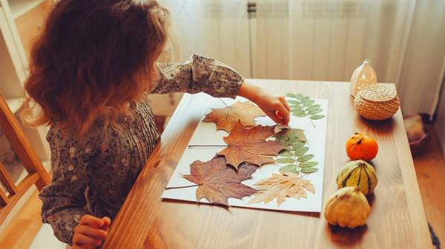
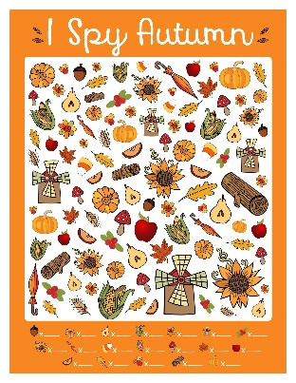
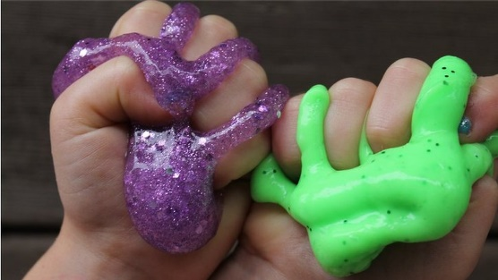

Autumn arts and crafts
https://www.bbc.co.uk/cbeebies/joinin/dualwa-five-autumn-arts-crafts-ideas-kids

In the Five Ways to Wellbeing explored different ways of being during the Half Term whether it be playing or resting. Each are important to nurture ourselves ready for the term ahead.

Let’s rest! Use each of your senses to mindfully seek nurture and self –care.
Looking and listening
I wonder what changes you have noticed in nature during Autumn. BBC Autumn watch has some top ideas for things to see and listen to.
https://www.bbc.co.uk/cbbc/shows/autumnwatch-on-cbbc
Touch
What brings you comfort in the Autumn days? A hug, a special blanket or toy. Build an Autumn den using pillows and snuggle up!
Alternatively build a den in nature!
https://www.woodlandtrust.org.uk/blog/2019/10/how-to-build-a-den/
Taste
Have you noticed the seasonal fruit and vegetables during Autumn. What new recipes will you try?
https://www.bbcgoodfood.com/howto/guide/autumn-cooking-projects-kids
https://www.nationaltrust.org.uk/lists/seasonal-autumn-recipes
Smell
I wonder how many of you have noticed the different smells of Autumn; cold crisp mornings, fallen leaves and a crumble cooking!
Read or write an Autumn poem of all your favourite smells! Check out Shirley Hughes Autumn book.

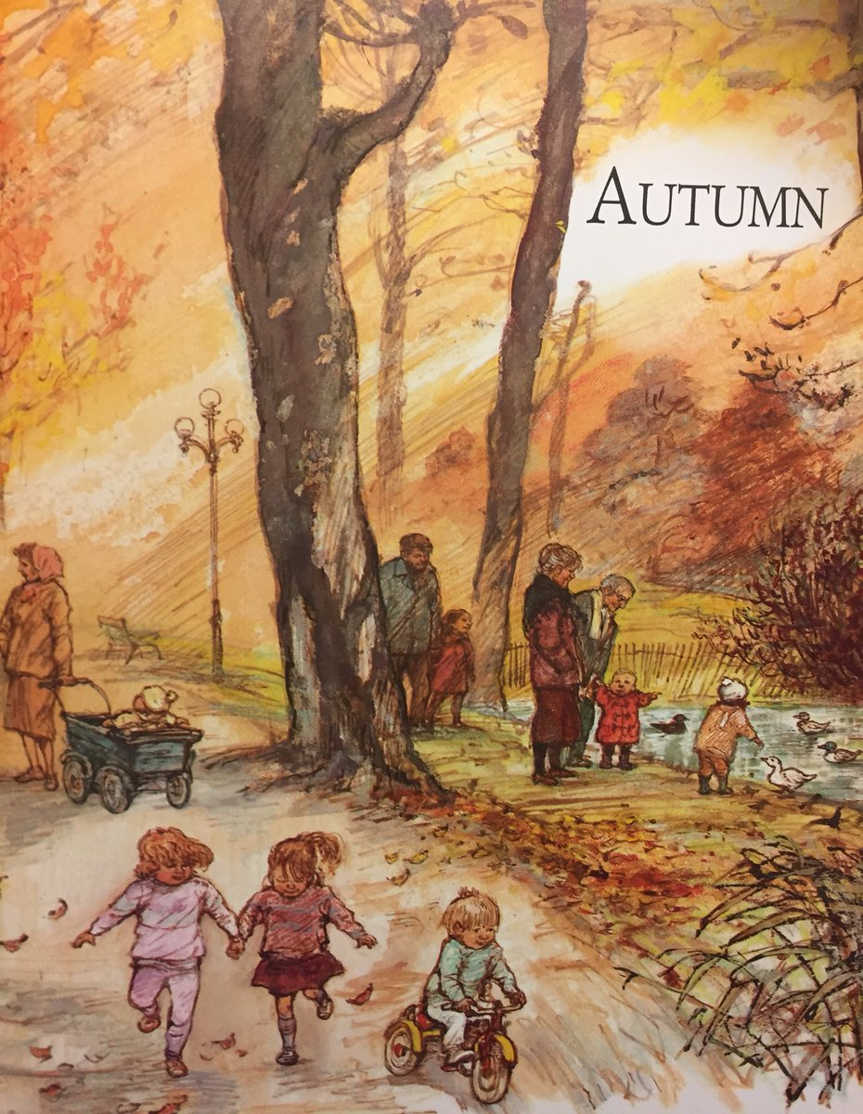

Rest and play!
Remember your feelings are not right or wrong, they simply exist. Try to meet them using the school’s PACE model. P: Playfulness, A: Acceptance, C: Curiosity, E: Empathy.

