Class 1 Activities to support Home Learning
Phonics  Collect bottle tops and write a letter of the alphabet on each one.  How many different words can you make?  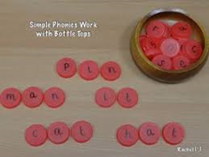 | Maths  Go for a walk, collect 21 stones/pebbles. Write a numeral on each one from 0-20. Now can you put them in order, close your eyes, ask an adult to remove 1, 2 or even 3 numbers –which ones are missing?  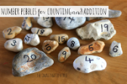 | Writing  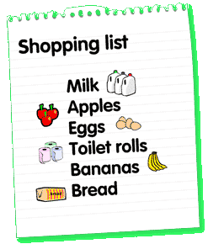  Can you write a shopping list for a grown up so that they don’t forget anything – make sure you include your favourite treat!. | Expressive Art and Design/Art  Can you build the Three Bears’ cottage? Use a box or maybe some Lego. Can you make some furniture too?  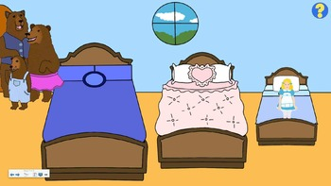 | Expressive Art and Design/ Design and Technology  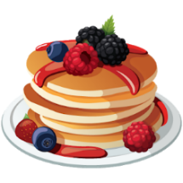  Can you make some breakfast pancakes for Goldilocks so that she doesn’t eat the Bears’ porridge!
Understanding the World/Geography  Where would you most like to go on holiday?  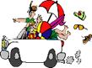  Why?  Who will you take with you?  What is it like there? | Understanding the World/  Science  Go for a walk with a grown up, how many things in the list can you tick off?  Something red  A bug  Name two things  you can see in the sky  Find 4 pine cones  Find 2 tree stumps  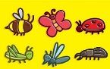 | Understanding the World/ Science  Make some slime with a grown up…eeeeew!  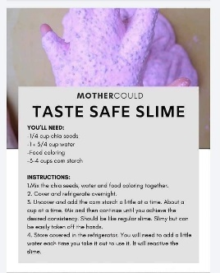 | PSED/PHSCE  Draw a picture to say Thank You to the NHS  send it to  ghccomms@ghc.nhs.uk  Don’t forget to write your name, age and the name of your school. | Expressive Art and Design/Music  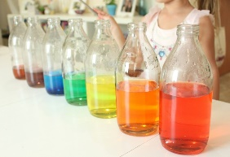  Collect 5 bottles and fill with water to different levels – blow over the top and see if you can hear the different sounds each one makes. Can you make a sound pattern?

