Time /Day | Monday | Tuesday | Wednesday | Thursday | Friday
8:50 – 9:00 | Get ready for your day, sign in to your first lesson Home Learning Kit: Paper, a pencil
9:10 – 9:30 | Phonics  Reception  Letters and Sounds – Lesson 16  Our learning objective is to learn the long ‘oo’ digraph  https://www.youtube.com/watch?v=Nw_6ZaV3KpE&feature=youtu.be  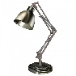  Year 1 – Lesson 16 – Our Learning Objective is: To read adjacent consonants and short vowels  https://www.youtube.com/watch?v=66VrNnJSDPw&feature=youtu.be | Phonics  Reception  Letters and Sounds– Lesson 17  Our learning objective is to learn the short ‘oo’ digraph https://www.youtube.com/watch?v=MDysETvGN_I&feature=youtu.be  Year 1 - Lesson 17 – Our Learning Objective is: To read adjacent consonants and short vowels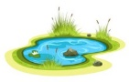  https://www.youtube.com/watch?v=qDBRiSU6zSg | Phonics  Reception  Letters and Sounds -Lesson 18  Our learning objective is to learn the ‘ar’ digraph  https://www.youtube.com/watch?v=IUHj1V-KYeg&feature=youtu.be  Year 1 – Lesson 18 - Our Learning Objective is: To  read adjacent consonants  and short vowels  https://www.youtube.com/watch?v=NjJzf171tZw&feature=youtu.be | Phonics  Reception  Letters and Sounds - Lesson 19  Our learning objective is to learn the ‘or’ digraph  https://www.youtube.com/watch?v=HbRKL68I1WQ&feature=youtu.be  Year 1 Lesson 19 – Our Learning Objective is:  To read adjacent  consonants and  short vowels  https://www.youtube.com/watch?v=ckqNWTB5c4M | Phonics  Reception  Letters and Sounds – Lesson 20 –Review of the week’s digraphs  Our learning objective is  Year 1 Lesson 20 - Our Learning Objective is: To read adjacent consonants and short vowels  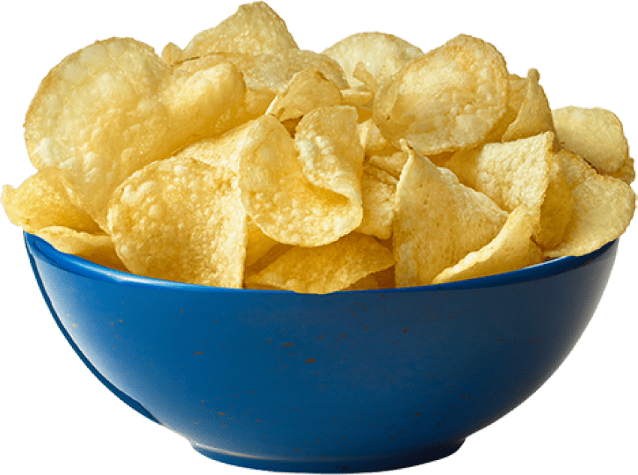  https://www.youtube.com/watch?v=W9pMGELqNEc
9:30 – 9:40 | Wake and Shake with a curriculum focus  Months of the year - https://www.youtube.com/watch?v=SSl-SbVz2oA  Counting in 2’s - https://www.youtube.com/watch?v=OCxvNtrcDIs  Counting in 10’s - https://www.youtube.com/watch?v=W8CEOlAOGas
9:40 – 10:00 | Name Writing practice using cursive script. Follow the link below and search for particular letters that your child may need to see written as a model. You can either use the name card sent home or write on a piece of paper.  https://www.youtube.com/results?sp=mAEB&search_query=%23FindMisterTeach | Funky Fingers –  Take a line for a walk and then find things to place on the lines. How many beautiful lines can you make?  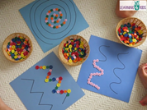 | Funky Fingers Cheerio Caterpillars  Thread cheerios onto a pipecleaner or piece of wool and hang them in your garden for the birds.  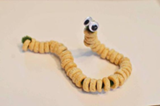 | Funky Fingers  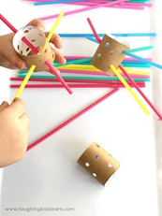 | Name Writing practice using cursive script. Follow the link below and search for particular letters that your child may need to see written as a model. You can either use the name card sent home or write on a piece of paper.  https://www.youtube.com/results?sp=mAEB&search_query=%23FindMisterTeach
10:00 – 10:15 | Snack and a drink
10:15– 11:15 | Literacy -  Our text is Goldilocks and the Three Bears  Reception and Year 1  Our learning objective is: To box up a recycled story  https://classroom.thenational.academy/lessons/to-box-up-a-recycled-story-ctgk8c  Activity  To create your own story and use pictures to help retell and sequence the story | Mathematics  Number focus  Reception –  Our Learning Objective is: Solving mathematical problems using numbers within 10  https://classroom.thenational.academy/lessons/applying-knowledge-of-numbers-to-ten-to-solve-mathematical-problems-cmtkjr  Activity  Problem solving stories  Year 1  Our Learning Objective is: To add amounts by counting on using a number line  https://classroom.thenational.academy/units/addition-and-subtraction-within-20-79fd  Year 1 challenge –  Our Learning Objective is: To use number bonds when subtracting  https://classroom.thenational.academy/lessons/using-number-bonds-when-subtracting-c9h3jd | Literacy –  Our text is Goldilocks and the Three Bears  Reception and Year 1  Our Learning Objective is: To write the opening to a recycled story  https://classroom.thenational.academy/lessons/to-write-the-opening-to-a-recycled-story-6rwkct  Activity  To write the opening scene to your recycled story. Adult to scribe and child to add words that can be phonetically written/tricky words. | Mathematics  Number focus  Reception  Our Learning Objective is: Using the language of ordinal numbers 1st – 10th  https://classroom.thenational.academy/lessons/using-key-vocabulary-associated-with-ordinal-numbers-1st-to-10th-6dgp4r  Activity  Using and applying the language of order  Year 1  Our Learning Objective is: To subtract by counting back using a number line  https://classroom.thenational.academy/lessons/to-subtract-by-counting-back-using-a-number-line-cgr36d  Year 1 challenge  Our Learning objective is: To use doubles to calculate near doubles  https://classroom.thenational.academy/lessons/using-doubles-to-calculate-near-doubles-60rk6t | Mathematics  Reception  Our Learnng Objective is: to learn about capacity as a measure  Mathematics  Reception  https://classroom.thenational.academy/lessons/describing-the-capacities-of-objects-and-using-language-about-capacity-65h3gd?activity=video&step=1  Year 1  Year 1  Our Learning Objective is: to measure and compare capacity of different containers https://classroom.thenational.academy/lessons/comparing-capacity-70v68t?activity=video&step=1
11:15 – 12:00 – Free Play
Well done for working so hard this morning everyone! Now it’s time for lunch and a little play outside!
1:15 – 2:00 | PE – PE at home - Jumping  PE lesson on JUMPING for Reception & Year 1 - YouTube  or with a grown up you could go for a bike ride, a scoot,,go for a jog or a lovely long walk. The main thing is to exercise so that you raise your heart rate. | Reading –  Tricky words practise – reading and spelling them. You could use magnetic letters and spell words on the fridge or your letter cards. Go on a letter hunt, make as many words as you can with the letter cards in 5 minutes | Reading  Tricky words practise – reading and spelling  Letters and their sounds practice  Using the letters to make words. Look at the links for ebooks on the class 1 page. | PSHCE  Our Learning Objective is to understand the importance of keeping clean and to know where germs may be hiding.  https://classroom.thenational.academy/lessons/hidden-germs-cgrkce?activity=video&step=1  R.E. Which Stories are special?  This week we shall look at stories that are special to Christians. This is a story that Jesus told.  https://www.bbc.co.uk/teach/class-clips-video/religious-studies-ks1-the-christian-story-of-the-good-samaritan-and-the-lost-sheep/zr7wxyc  This link has two stories. The second “The Lost Sheep” is for this week. | Outdoor Learning  Reception  Our Learnng Objective is: To recap our learning about shapes and their names. To find different shapes in our environment and name them  Wrap up warm, go for a shape walk. What shapes can you find in the environment? Can you see some bricks, windows, doors? What shape are they? Can you find any circles or triangles?  Year 1 Our Learning Objective is: to recap our learning about shapes and identify them in our environment. To talk about the shape properties.  What shapes can you find in the environment? Can you see some bricks, windows, doors? What shape are they? Can you find any circles or triangles? Can you find any 3D shapes around the house? Can you find a cuboid? Or a cylinder? Or a Sphere?
 |  | Science  Reception  Our Learning Objective is: To talk about what you can see outside in winter.  https://classroom.thenational.academy/lessons/to-name-things-that-you-can-see-outside-in-winter-c4t3ec  Year 1  Materials  Our Learning Objective is: To find out which materials float and sink  https://classroom.thenational.academy/lessons/which-materials-float-and-sink-cdj66c  Activity  Experiment to find out which materials float and which sink | Design and Technology –  Make a cottage for Goldilocks to live in.  You might want to build it using Lego, building bricks or cardboard boxes.  Perhaps you could paint it and make some furniture too.  Can you make windows and doors that open? What kind of roof will it have?
2:00 – 2:30 | Phonics Play – Parents resources - Phase 2/3 interactive games  Follow the link to Phonics Play https://www.phonicsplay.co.uk/  and use the log-in details below.  User name: jan21  Password: home  If you want to select interactive games to play, we have covered all letters and sounds in Phase 2 and 3 so far in Class 1 | Understanding the World /Geography – my community  Reception and Year 1  Our Learning Objective is: To understand what it means to have a job  https://classroom.thenational.academy/lessons/to-understand-what-it-means-to-have-a-job-c5hpad | Phonics Play – Parents resources - Phase 2/3 interactive games  Follow the link to Phonics Play https://www.phonicsplay.co.uk/  and use the log-in details below.  User name: jan21  Password: home | Geography Year 1 – London  Our Learning Objective is to find out how people move around in Londoin  https://classroom.thenational.academy/lessons/how-do-people-move-around-in-london-68wkat | Music – This is Me  Music – This is Me  https://classroom.thenational.academy/lessons/me-and-my-family-part-2-6hk36t
Dear Parents and Carers,
We want to see how your child is getting on with their home learning activities and so please send piccies/videos in so that we can continue to support them remotely and monitor their progress. If your child is in Reception, please do this by using Tapestry.. Click on the ‘Observation’ tab and clicking ‘Add Observation’ you can then write a little bit about how your child has managed the activity and add photos etc by scrolling to the bottom of the page and clicking on ‘Add Files’. Don’t forget to then click ‘Save’ on the bottom right. If your child is in Y1, please use the Outlook email address to send photos to csymonds@steammills.gloucs.sch.uk or jevans@steammills.gloucs.sch.uk You can do this by clicking on the paperclip or camera icons and then attaching to the email. Again, if you could write a little about how your child managed with their task that would be great.
The Class 1 Team

