ADULTS  Steam Mills Primary School  Our Parent Charter | ARTICLE | CHILDREN
- Be a good role model to our children • Monitor what our children watch on TV and look at on the Internet  - Provide our children with a healthy, balanced diet and access to a healthy lifestyle | ARTICLE 19  You have the right not to be harmed and to be kept safe  ARTICLE 27  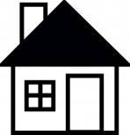  You have the right to a good standard of living | - Respect ourselves and others in school and at home  - Listen to our parents’ wishes and ‘boundaries’ when at home  - Tidy up after ourselves and take responsibility for our own behaviour
- Make sure our children always attend school, arriving on time every day  - Allow our children to relax and have some play time in the evenings, as well as completing homework | ARTICLE 28  You have the right to learn and to go to school  ARTICLE 31  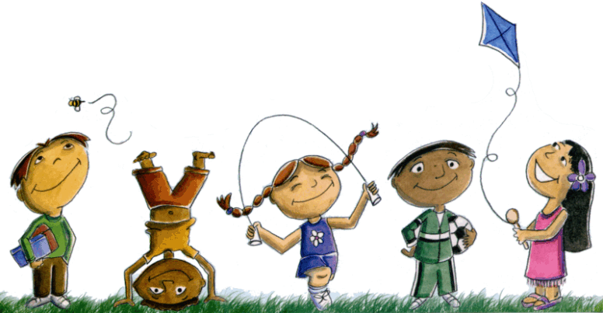  You have the right to relax and play | - Try our best at all times throughout the school day, and when completing homework  - Understand that there must be a balance of work and play at school and at home
- Listen to and communicate openly with our children  - Be truthful and honest  - Offer support to our children in any way that they need | ARTICLE 12  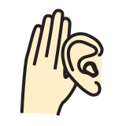  You have the right to say what we think should happen and to be listened to | - Talk to our parents about any concerns or worries  - Express ourselves clearly, articulately and with respect and awareness of those around us

