ADULTS  Steam Mills Primary School  Library Charter | ARTICLE | CHILDREN
- Make sure children are read to or read with regularly, both at home and at school  - Check children are reading a variety of books  - Point children in the right direction when choosing books, researching topics or finding information  - Encourage children to reflect on the books they read | ARTICLE 3  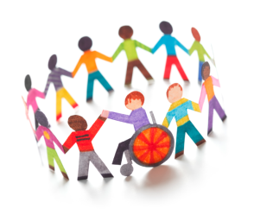  All adults should do what is best for the children in their care. This includes teachers, doctors, parents and carers | - Enjoy choosing a range of books to take home and read with our parents  - Actively ask questions and use books to carry out research and find information  - Reflect on the books we read, and enjoy discussing them with our family, friends and classmates
- Give children appropriate answers to questions they may ask  - Direct children to books where they can find answers themselves  - Provide a variety of reading material for children, including newspapers and magazines | ARTICLE 17  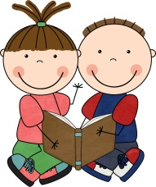  You have the right to get information that is important to you from books, magazines, newspapers and television. | - Use a variety of sources to carry out research and find information  - Be confident in asking questions and independently looking for information in books  - Librarians to be in the library at lunch time to support their peers in their reading and borrowing of books
- Ensure there are a range of books available for different ages and levels  - Make sure children are given a choice of the types of books they read  - Provide children books that can challenge and extend their learning | ARTICLE 28  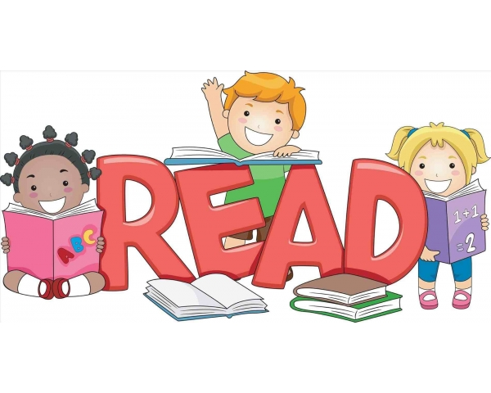  You have the right to a good quality education | - Take care of all books and equipment to make sure everybody has access to them at all times  - Be responsible for independently reading and borrowing a variety of books  - Return and change books regularly

