|  |
| --- |
| We will be ‘Word Collectors’ as we meet and explore new words and explore their different meanings and use them in our talk…  Non-fiction, fiction,  Human features = features that humans have made or influenced= houses, roads, parks, mine, mill  Physical features = natural features of the earth trees, hills, rivers  material = what an object is made of.  seed, germinate, root, shoot, stem, leaf, bud, flower, plant  **A picture containing text, newspaper  Description automatically generated**butterfly, cocoon, caterpillar, flass, emerge  My Rights and My Responsibilities  listen consider kindness  fairness right respect  responsibility friend honesty  thoughtfulness share disability  name family education  environment |

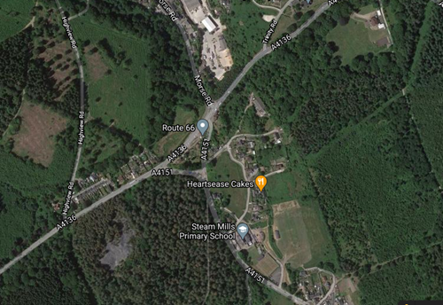

As Geographers we will be using different maps to help us learn about our local area.

We will be spotting key features and exploring how our environment has changed over time.

We are going to be reading lots of different texts to help us with our learning.

Some to help us understand the passing of time,

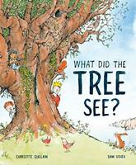

… a traditional tale to help us with our writing and scientific understanding…



…non – fiction texts…

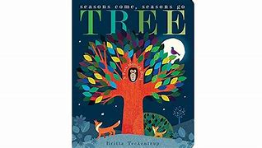

…and old favourites.

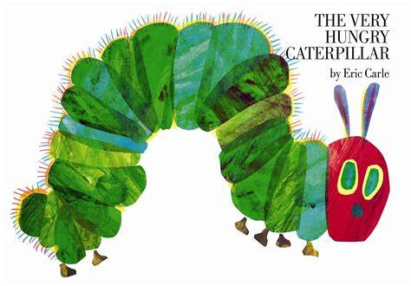

**Class 1 Term 3**

**Our Wonderful World…**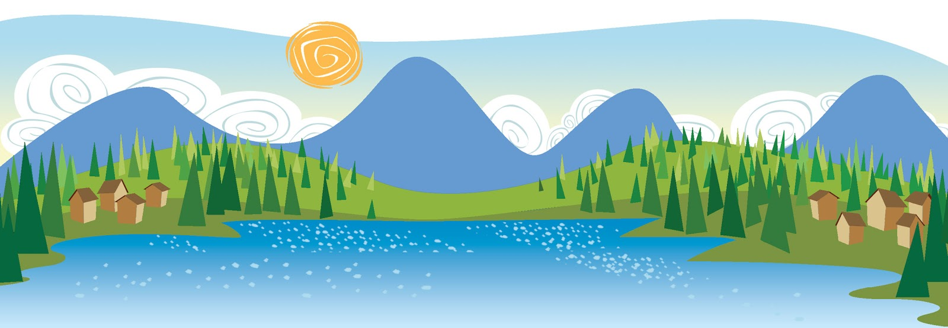



As Scientists we will be learning about daily

and seasonal weather patterns in the UK.

We will be investigating the best conditions for growing a seed and grow our own beanstalk…

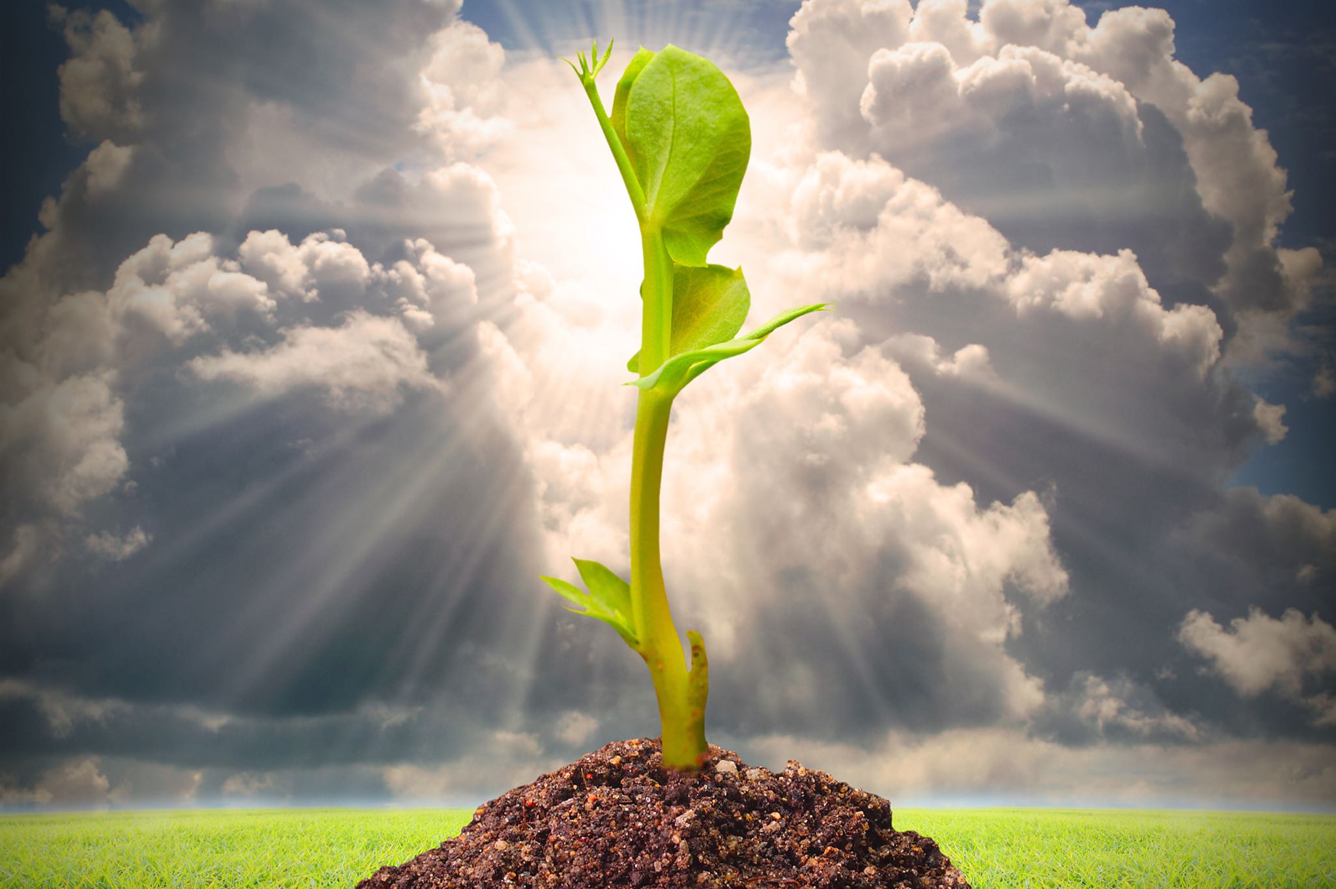

…we will make a cress caterpillar, 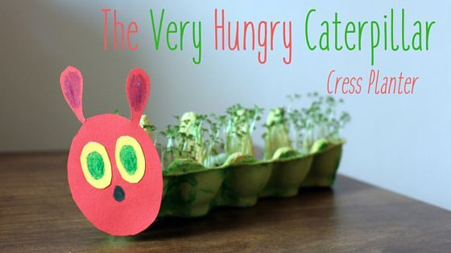

and as we find out more about lifecycles, we will even grow butterflies!

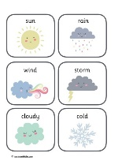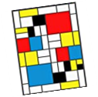

As Historians we are going to find out a little bit about how our school and Steam Mills has changed…

Our Key Curriculum Drivers ‘Aspiration’, ‘Communication’ and ‘Knowledge of the World’ are at the heart of our teaching and curriculum design and in the EYFS at Steam Mills, they look like this…

|  |  |  |
| --- | --- | --- |
| Aspiration | Communication | Knowledge of the World |
| We want our children to have a generous spirit and be a good friend. To understand the importance of being ‘a blessing' and to understand that to have good friends, you have to be one. To always think about others and know that we do not all like the same things or live in the same way – we are all unique.  To begin to understand that we all have rights, responsibilities and should show respect to each other every day.  To show that we are ‘ready to learn’ whether this is when we are playing or coming together as a group to readily celebrate our own success and that of our friends in all circumstances.  To always try our best, to be confident, independent and resilient learners.  We want our children to be responsible and have an awareness of changes in their environment and how they can play a part in preserving its beauty and caring for it through small gestures and lifestyle changes. | We want our children to speak clearly and audibly, to use grammatically correct structures and sound articulation.  Using traditional stories, nursery rhyme and stories that focus particularly on a message/educational programme we will expose our children to a breadth of language from across the ages.  We will broaden and enrich their language bank and understanding of subject specific vocabulary through their play and exploration and through deliberate teaching/subsequent learning experiences and interactions with adults in school.  New vocabulary will be celebrated; it will be displayed and revisited over time as well as being incorporated into everyday conversations where applicable.  We will encourage our children to have a voice, to share their opinions and to understand the importance of being able to justify the choices they make with clarity. | In developing the children’s essential knowledge and to prepare them for what they need to know for future success (cultural capital), we will build on from prior knowledge about themselves.  We will continue to expose our children to the works of famous artists and in doing so, explore the gifts and talents they bring to their class/peers in doing this, they may also consider this pathway for their future.  We will also tailor the learning to explore the changes over time to the environment in which they live, touching on the emerging environmental issues in our locality and how they can play an active role in addressing them.  Through Forest School sessions, we will learn about seasonal change, new life and signs of Spring and the changes that will be taking place in the coming months.  Through shared texts we will explore how **our** community has evolved and the changes that have taken place over time. |

*Whilst we have planned our learning and development around the broad theme of ‘Our Wonderful World’, the learning direction can often take an unexpected twist and turn as we respond to and follow the thoughts, ideas and interests of the children in Class 1.*

*This is in line with the statutory overarching principles that guide our practice and provision in the EYFS. Steam Mills is a Rights Respecting School and as such, when planning for our pupils, we give our consideration to the articles that underpin our ethos and teaching.*

*Article 2 – The right to be treated fairly and without discrimination Article 3 – The right for decisions to be made with the best of intentions Article 6 – The right to survive and develop in the best possible way Article 12 – The right to be heard Article 28 – The right to an education Article 31 – The right to relax, play and take part in a wide range of activities*

We always like to make sure the children help to lead our topics, so we will be asking them about what else they would like to find out about...and then we may find that we deviate from our original plan!

Newnham, Newent and St Fagan’s are good places to visit, to look for different architecture.

**Places to Visit:**