ADULTS  Steam Mills Primary School  Assembly Charter | ARTICLE | CHILDREN
- Make assemblies interesting, informative and relevant to all children  - Allow children to reflect on what is being discussed  - Try to make assemblies current and relevant to subjects and topics currently being studied | ARTICLE 17  You have the right to get information that is important to you from books, magazines, newspapers and television | - Be reflective about ourselves both in and out of school  - Take assemblies seriously and use the information given to help improve our attitudes and lives  - Listen to all assemblies and establish links to our own lives, experiences and beliefs
- Make sure that children come into assembly sensibly, quickly and quietly  - Ask a range of interesting questions to ensure children are listening and are engaged | ARTICLE 28  You have the right to a good quality education  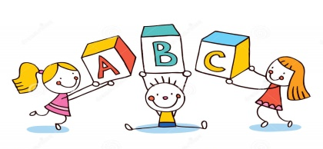 | - Be silent, respectful and well-behaved during assemblies  - Concentrate on the messages and advice that assemblies give and use them to reflect on our work and attitudes
- Choose ‘Head Teacher’s Awards’ based on children’s attention to their responsibilities and positive attitudes  - Reward good work and positive behaviour | ARTICLE 29  You have the right to reach your full potential and to be the best you can be | - Listen to others’ achievements and encourage classmates  - Speak loudly and clearly to other children and adults during assemblies, and when sharing our good work

