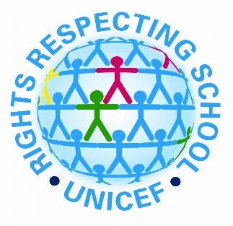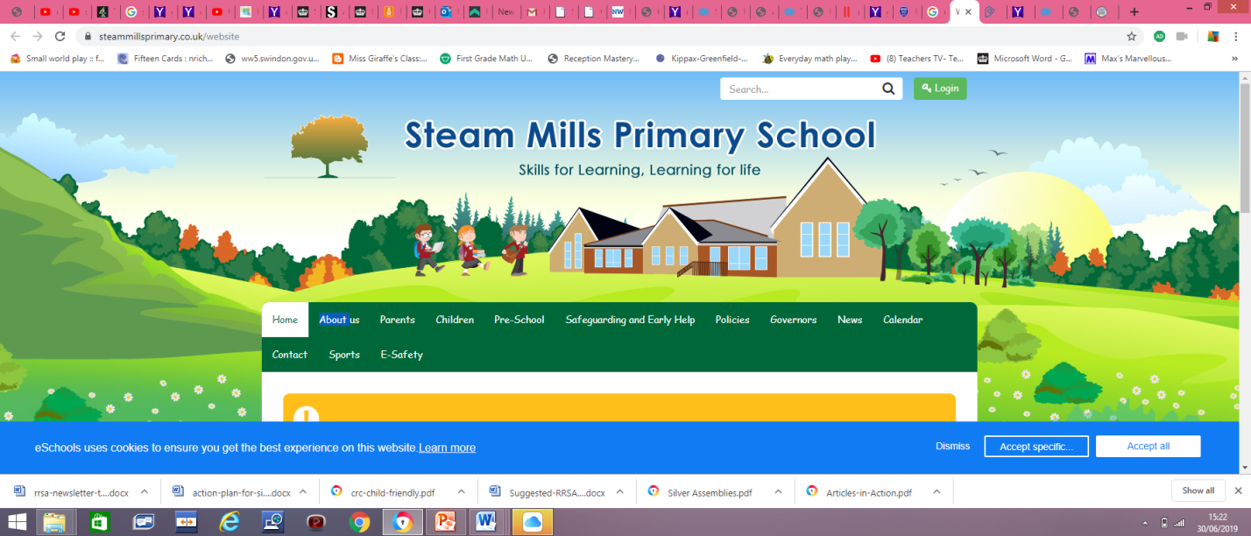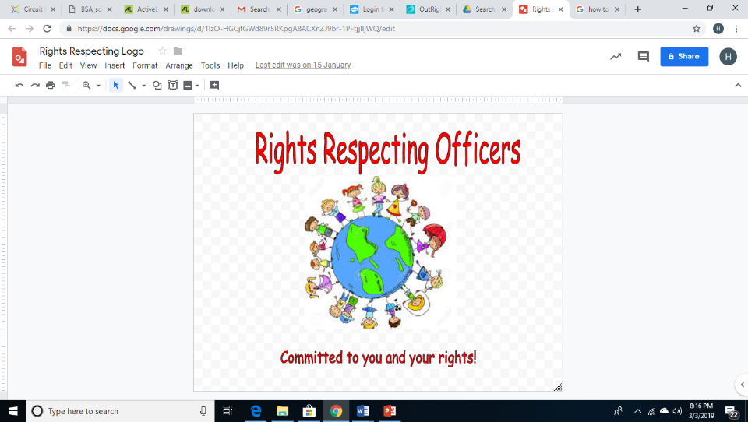

**Information about the Rights Respecting Schools Award**

**Steam Mills Primary School**

**How are we a Rights Respecting School?**

As a school we have already achieved our Bronze (ROC) Award. We are working towards our Silver and as a results from Nursery to Year 6, we will be teaching children about their rights. Each class will be making a class charter which will be agreed and signed by the children and shows how they can make sure everybody’s rights are respected.

At Steam Mills Primary, we believe children have a voice so we have chosen RRSA Officers from the school to help us develop a Rights respecting ethos as members of the Steering group. The Steering Group will be formed by children, governors and members of staff and they will work to make sure all children are taught about their rights.

**Why are we a Rights Respecting School?**

We decided to become a Rights Respecting School because we want Steam Mills School to be a better place for everyone. We want to teach children; not only about their rights but also help them to respect the rights of others. Learning about their rights makes everyone think more about others and how our actions would affect them.

**How can you help?**

We are passionate about children’s rights and believe that respecting them will give children the best education possible. Talking to your child about their rights and how they can respect the rights of other children has been shown to improve children’s social awareness and learning in class. You should talk about them and how important they are. Rights respecting classrooms where children feel safe, happy and well will help the children to learn more in class.

If you want to find out more look at the UNICEF website: [www.unicef.org.uk](http://www.unicef.org.uk) . There is also more information on the school website. [www.steammillsprimary.co.uk](http://www.steammillsprimary.co.uk)

**What is the UNCRC?**

UNCRC stands for ‘United Nations Convention on the rights of the child’. It was created by UNICEF and has 54 articles which are all the rights a child has. It builds on the basics that a child has the right:

* To survival
* To develop to the fullest
* To protection from harmful influences, abuse and exploitation
* To participate fully in family, cultural and social life.

**What is the RRSA?**

The RRSA is awarded by a charity called UNICEF. UNICEF (United Nations International Children’s Emergency Fund) work hard to help children and families all over the world. They work hard to make sure that all children can enjoy their rights by upholding the UNCRC. We all deserve our rights and they cannot be taken away from us.