Steam Mills Primary
Newsletter
09.10.20

Dear Families,

Photos

Diary Dates

October
12th Flu Immunisations YR-Y6
22nd Last Day – Term 1 – Superhero non-school uniform
23rd INSET DAY

November
2nd Start of Term 2
The visit by Tempest Photography went very smoothly yesterday and the children tried very hard to show their biggest smiles . As previously communicated, please try to order on-line wherever possible. You have until 22nd October 2020 to qualify for the free delivery to school.

Lunches
We have experienced a number of cases where parents are certain they have booked school lunches but this information has not registered on the ParentPay system. Miss Agg has contacted ParentPay about this issue and they have confirmed that there should not be any problem with booking well in advance but parents much check the “Confirm Booking” button before leaving the page, we are told this is bottom right of the screen.

Please could parents check bookings on a weekly basis and if there has been an error/omission, contact the school to see if it is possible to order an emergency lunch for your child or provide your own packed lunch. Thank you.

Infection control: Please continue to protect your child's bubble
We are fully staffed and want to maintain this; bubbles are separated during the day to minimise the spread of potential infection. This is to prevent the whole school needing to close if we get a Covid-19 case.

We need all parents to continue to maintain the integrity of keeping bubbles apart when dropping off and collecting.

FACE COVERINGS must now be worn by all visitors/parents/relatives/carers whilst on the school site (including yard) for whatever reason and for however long from Monday 12th October.

We need all parents to continue to maintain social distancing rules with other parents and if approaching staff. Please keep your child close to you until handing over and please leave the site promptly. Once a teacher is present to supervise your child, please leave the school site.

Please be mindful that if you are collecting at the earlier drop off time, other classes are still being taught with windows open and need to concentrate, so please keep younger children close to you.

Please phone in with queries and avoid going to reception.

Thank you in support of our rules; we appreciate that dropping off and collecting is different to before lockdown, but the safety of all is paramount and we need to work together to prevent bubbles closing.

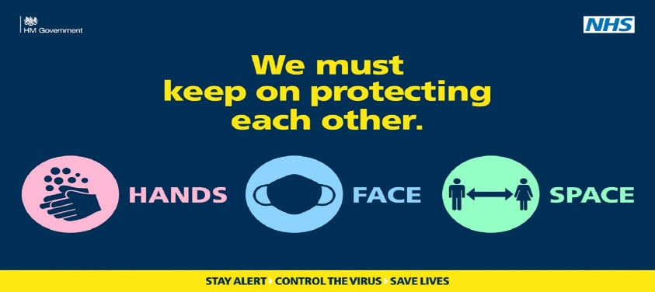
Best wishes,
Mrs Davis

