ADULTS  Steam Mills Primary School  Healthy Eating Charter | ARTICLE | CHILDREN
- Make sure all children are eating enough food and drinking enough water throughout the day  - Ensure children are given access to a range of different foods, including meat, fish, vegetables and fruit | ARTICLE 6  You have the right to be alive | - Eat regularly throughout the day, and make sure that you finish each meal you are given, or eat as much as you can, to make sure you have enough energy for the day  - Communicate with adults to make sure the quality and amount of food given in enough for you
- Make sure each menu each day is as healthy as possible, and that the school’s ‘healthy snack bar’ is promoted and easily accessed  - Allow children to drink water from a bottle brought in from home throughout the day | ARTICLE 24  You have the right to good food, clean water and good health care  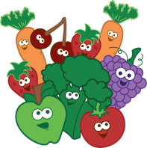 | - Choose as healthy a meal as possible, making full use of the ‘healthy snack bar’ and/or fruit from home  - Bring a water bottle from home into school every day, and be sure to drink regularly from it
- Provide the option of vegan and vegetarian meals for children and adults  - Provide meals for different faiths e.g. Halal  - Prepare and provide a range of options and choices for children at lunchtime. | ARTICLE 30  You have the right to use your own language and practise your own culture. | - Eat politely in the dining room, using correct cutlery and asking before leaving the hall to go to the toilet.  - Take responsibility for eating a healthy and balanced diet.

