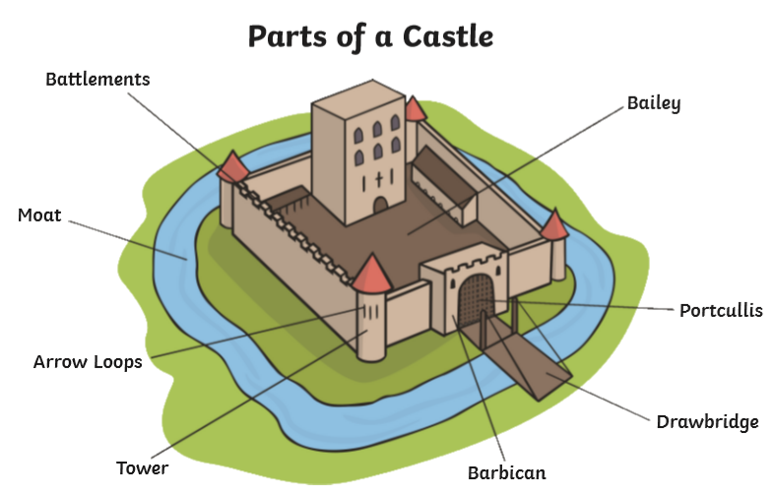
Class 2 Once Upon A Forest Summer Term
The Royal Forest of Dean
- Offa, the King of Mercia built a dyke to seaprate England from Wales. English lords built many castles along the dyke as a defense barrier.

- Known as the Royal Forest of Dean since the Norman conquest in 1066, until 1971 when it was deforested by the royal family.

- The forest was used as a hunting ground by the Norman rulers, this was continued by the Tudor kings

- Verders were appointed to protrect the land for the king. The PseechHouse was built in 1682 to act as a parliament for freeminers and verderers. It is the oldest court in England. It still meets four times a year.

Key Words
Monarch | A monarch is a king or queen, emperor or sultan who rules over a land
Parliament | Where the politicians meet to decide laws
succession | This is the order in which a monarch’s family will take over the throne
medieval | A period in time also known as the middle ages running from the 5th to the 15th century
defence | The act of protecting
invader | To enter by force as an enemy
Verderer | An officer of the court in charge of the kings forest

