Please use this grid as ideas for learning opportunities. Anything I am asking you to do is not as an expectation. I have included a link to curriculum objectives at the bottom of Class 2 webpage. Please feel free to pick objectives that are manageable for you and you can resource at home home.
Reading/Phonics  Pick a book from Oxford Owls. Answer some Victor Vocabulary questions – these can be found in your yellow homework books and as a pdf on the web page | Writing  Write a diary entry about something you have done while you have been off.  Remember to make your handwriting beautiful!  Add to it daily in the coming weeks, see yourselves as history keepers. |  | Maths  Learn how to tell the time to o’clock and half past the hour. |  | Science  How many different materials can you find around the house?  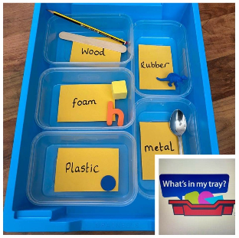
RE  Draw a story board of the Easter story from when Jesus arrived in Jerusalem to when his tomb was discovered. | PE  Play catch and count how many catches you can do without dropping the ball. |  | DT  Help make lunch by cutting and chopping the ingredients. |  | Art  Spread the hope – paint, draw, colour, collage a rainbow and put it in your window.
PSHE  (Personal Social and Health Education)  Enjoy relaxing together. Download Smiling Mind app- it’s free. |  | History  Research some local mining history and write down two facts about it. |  | Practical Learning  Enjoy the sunshine, get out in the garden and plant some seeds or bulbs if you can.
Remember…
