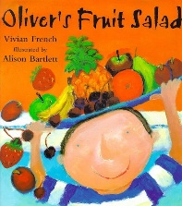
Key Texts
Summer Term 5 2026
We will incorporate this term’s learning objectives into the children’s play- lead by their interests.
Down at the bottom of the garden…….
Key Vocabulary – caterpillar, chrysalis, growth, bud, soil, healthy

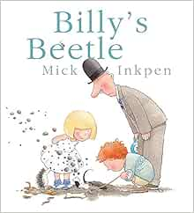
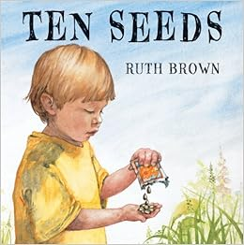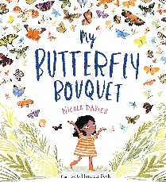
Communication and Language
Patch the Dog
Sound of the Week(s, a, t, p, i, n,)
Letters and Sounds Phase 1

Use a wider range of vocabulary
Use talk to organise themselves and their play
Sing a large repertoire of songs

We will share a selection of fiction and non-fiction texts to help the children learn about mini beasts, life cycles, growth and gardening.
Personal, Social and Emotional Development
Patch the Dog
Talk about how we are feeling - using words happy, sad, angry, worried
Be increasingly independent
Develop appropriate ways to be assertive
Following on from Ten Seeds- talk about patience; taking turns for resources, using timer, to wait turns to speak

Physical Development
Water play, Sand play, Dough disco,
Cosmic yoga,Dancing
Use one handed tools and equipment
Choose the right resources to carry out their own plan
Collaborate with others to manage larger resources, such as planks, tyres, crates and guttering

Literacy
Sound of the week (s, a, t, p, i, n)
Daily Nursery Rhymes
Spot and suggest rhymes in stories, songs
To understand that print can have different purposes- tickets, invites, lists
Use print and letter knowledge in early writing

Expressive Arts and Design

Singing Assembly (Thursday pm)
Explore different materials and different textures freely
Play instruments with increasing control to express feelings and ideas
Develop their own ideas and then decide which materials to use to express them
Sing the melodic shape of familiar songs

Understanding the World
Seven continents song
Celebration Assembly (Wednesday pm)
Plant seeds and care for growing plants
Begin to understand the need to respect and care for the natural environment and all living things
Talk about what they see, using wide vocabulary

Maths
Number of the Week
Daily Subitising activities 0-5

Describe a familiar route
Show finger numbers up to 5
Solve real world mathematical problems with numbers up to 5

Experiment with their own symbols and marks as well as numerals

