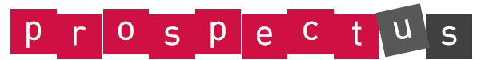
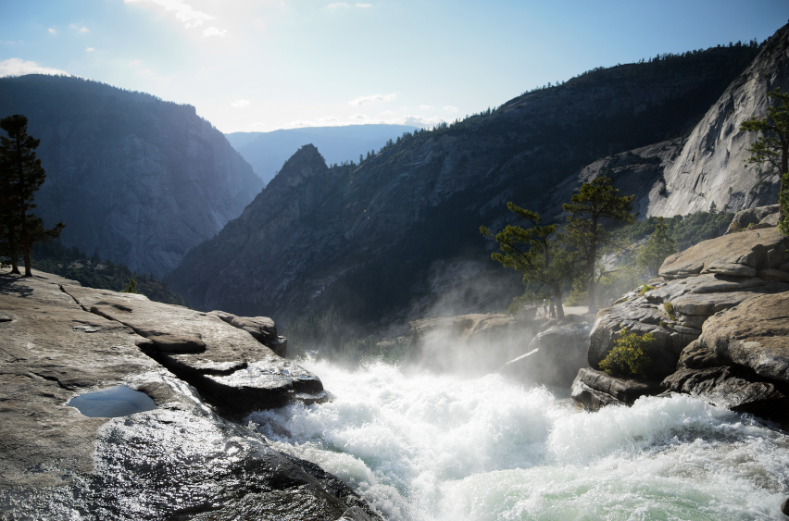

Wild Water! Year 5

Essential Knowledge

By the end of this unit children will know...

- Use their understanding to describe how rivers are formed; how the journey of the river progresses from source to mouth; the process of the water cycle.
- Describe and understand how settlements have been made around rivers.
- Carry out fieldwork at a local river, making observations and measurements, then recording using a range of methods, including sketch maps, plans and graphs, and digital technologies.

ASPIRATIONS:  Looking at typical jobs relating to water conservation and bridge architecture. Understanding how to carry out field work and recording data for team research. Investigating scientific careers. | ENTERPRISE:  The Great Bridge Challenge: Enterprise. Costing of resources to build the longest, strongest and cheapest bridge. | KNOWLEDGE & UNDERSTANDING OF THE WORLD:  Use maps, atlases, globes and digital/computer mapping to locate rivers within cities and counties in the UK and in the countries in the continents around the world.

Invite parents and carers into school for a celebration event. Create rivers using natural materials. Demonstrate the bridge models show video clips of green screen ‘news reports’ from Workington.
Possible School Performances/Assemblies
http://www.assemblies.org.uk/pri/346/water
http://www.assemblies.org.uk/pri/187/water-of-life

Celebrate

Energise
River Challenge Day
Dr. R Nile is to set the scene for practical challenges. Children are to build rivers using natural materials in the outdoor environment.

Explore

Children to research and watch news clips of natural disasters impacting on communities e.g. local flooding, bridge collapsing, tsunami.
Develop news reports through green screening to report on the events and the impact on the environment and community.

Launch

Secret River Scavengers
Team challenges using mapping skills in local school environment to carry out orienteering to find clues relating to UK Rivers.
Scavenge facts to create clues about a Secret River for presentation.

Wild Water! Year 5: Theme Content

Core Subjects: Links to theme

Personal Development

Foundation Subjects

Cultural
English
- Journalistic Writing – Children will write newspaper reports about flooding and the effect of bridge collapse on the community of Worthington.
- Explanation– Water Cycle/ Journey of the river/ erosion and corrosion.
- Poetry-shape poetry/ haiku.

Mathematics
Measures
- Fieldwork-length and depth speed of flow.
Data Handling
- Use data about UK/World Rivers to draw graphs and tables.
- Analyse data from statistics.
- Use mean, mode median and range.
Calculating
- The Great Bridge Challenge: Enterprise. Costing of resources to build the longest, strongest and cheapest bridge.

Science
Science:
- Changing State: Solids, liquids and gases – water.
- Study of the Water Cycle and its importance.

- River Ganges– symbolism and importance.
- Relevance of water in baptism.
- Biblical stories (floods-Noah).

Spiritual
Moral
      - Why do natural disasters—floods happen to good people?
- How does this make us feel?
- How do we express these emotions?

Social
      - Children will work collaboratively.
- They will learn to think and empathise with others when thinking about the impact of flooding on people and communities.

- How do we adapt to change in our lives – reflect on experiences of victims of natural disasters
- What lessons or strategies can we learn from this to support us in changes within our lives? – Link to transition.

Art and Design and Design Technology

History, Geography and Citizenship

Art: ‘Take One Picture’ Artist study on the work of Monet (Impressionism), and his piece ‘Water lilies’.
Design Technology: Design and build a bridge – selecting, joining and combining materials to make a strong bridge.

Music, Languages and Physical Education

Music: Creating a soundscape to describe the journey of a river.

History:
- Looking at why settlers throughout history have chosen to settle near rivers.
Geography:
- Map Skills – Locating Rivers in the UK and worldwide naming the counties, countries and continents where they can be found.
- Physical geography: Looking at the physical features of rivers, and the role of the Water Cycle.
- Human geography: Study of people and place – why do people live near rivers.
- Fieldwork in the local environment– observations, measurements and recording data using a variety of methods and digital technologies.

Computing

- Using Spreadsheets to organise and present data-Enterprise ‘Bridge Challenge’.
- Converting information to present using a range of software and devices.

