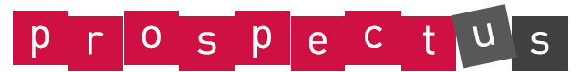
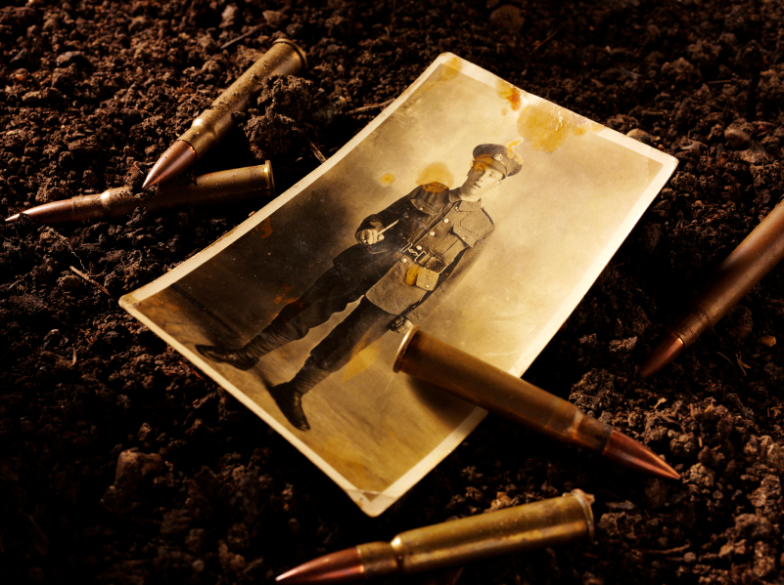

UKS2 The Great War: Trenches Warfare

Essential Knowledge

By the end of this unit children will know...

- The names of countries that formed part of the British Empire.
- The key events that triggered the start of the First World War
- What life was like for animals that served on the battlefields during the First World War?
- About key events during the first world war such as ‘The Christmas Truce’.
- How the war ended and the impact of the Treaty of Versailles
- The legacy of The Great War.

ASPIRATIONS:  Careers within the armed forces to defend our country. | ENTERPRISE:  Your school wish to hold an event to raise money for Help for Heroes. Develop a business plan! | KNOWLEDGE & UNDERSTANDING OF THE WORLD:  Identifying countries in the world who were involved in WW1 and how they have to live with the legacy of the conflict.

·

Come and Share
Children set up a gallery/museum to showcase the work that they have completed as part of their homework projects. Invite parents into school in the afternoon to share these with them.

Celebrate

Energise
Peace Party
Take part in a whole school WW1 Armistice celebration event/party with music and songs from WW1, food dances etc.

Explore

Special Edition!
Find out about how your local town or city will be commemorating the event. Become a journalist and create a special edition of the school newspaper covering the events being held locally. Interview local councillors etc.

Launch

Film
Listen to extracts from Michael Morpurgo’s best seller, War Horse.

UKS2 The Great War: Trench Warfare: Theme Content
: Theme Content

Core Subjects: Links to theme

Personal Development

Foundation Subjects

Cultural
English
- Children read a range of poems written about the experiences of world war one and evaluate the different perspectives that they show.
- Children read different accounts of ‘The Christmas Truce told in different ways and evaluate the differences between narrative accounts and factual eye-witness accounts.

Mathematics
Linked activities as suggested in ‘Trench Warfare’ Maths Quest

Science
Dinosaurs.
Discuss the contrasting attitudes held towards war by a number of different religions. Is there ever such a thing as a ‘just’ war?

Spiritual
Moral
What does the word ‘sanction’ mean? Discuss the morality of the armistice agreement. Were the Allied Forces right to impose such strong penalties on Germany—what was the impact of this?

Social
Children will work as part of both ability and mixed ability groups to create presentations about different aspects of WW1.

Research the different nations that formed the British Empire.
Find out about the different armed forces that formed part of the ‘Allied Forces’ - what countries did they come from?

Art and Design and Design Technology

History, Geography and Citizenship

Art
- Use a range of different artistic media to create evocative images of the trenches.
Design Technology
- Design, plan, make and evaluate a model of the trenches using a range of different materials.

History
- Children research the history and power of the British Empire.
- Children find out about key events that triggered the start of the First World War—placing them on a timeline.
- Children use a variety of historical sources to find out what life was like in the trenches during The Great War.
- Children research the lives of key women involved in the war effort.
- Children find out about the roles that animals played on the front line.
- Children find out about the events of ‘The Christmas Truce’ of 1914.
Geography
- Children use maps of Europe to identify: countries that once formed the British Empire, Countries that were part of the central powers during the First World War, Countries which formed the Allied Forces during the First World War, key areas of Europe affected by the Great War e.g. Northern France.

Computing

Children use ICT to research facts and publish/present their work in a variety of ways.

